**Name: Rubab Rafique Sap ID: 55565**

**Task 1:**

<!DOCTYPE html>

<html>

<head>

  <title>Task 1 - Class Change</title>

  <style>

    .oldClass {

      color: blue;

      font-size: 18px;

    }

    .newClass {

      color: green;

      font-weight: bold;

    }

  </style>

</head>

<body>

  <p class="oldClass" id="myPara">This paragraph has the old class.</p>

  <!-- Linking JavaScript -->

  <script src="web lab 8 task 1.js"></script>

</body>

</html>

const para = document.getElementById('myPara');

console.log("Old class:", para.className);

para.className = 'newClass';

console.log("New class:", para.className);

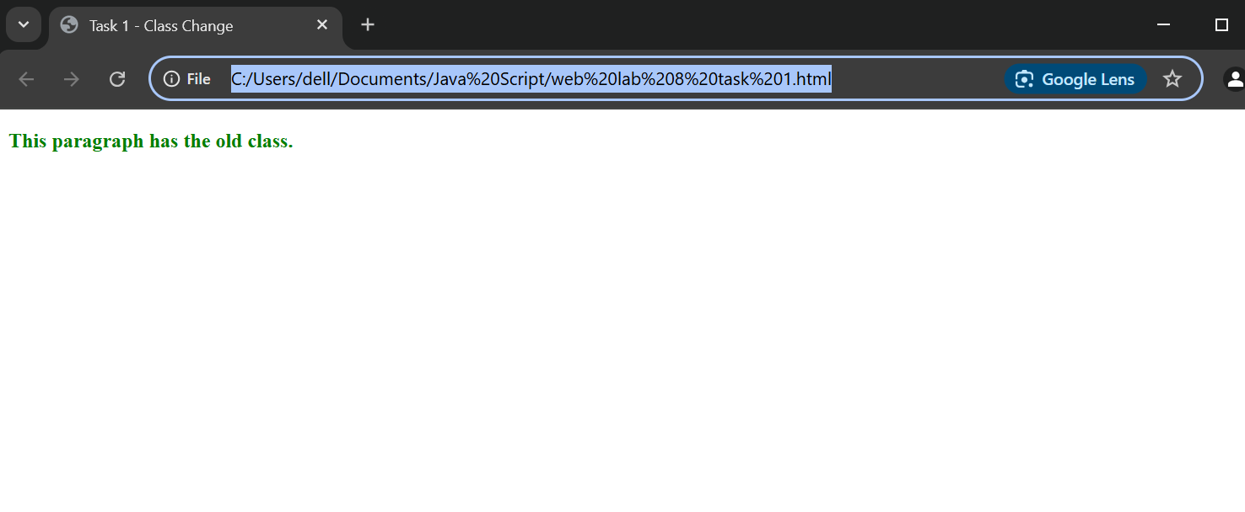

**Task 2:**

<!DOCTYPE html>

<html>

  <head>

    <style>

      #logIn {

        background-color: crimson;

        color: white;

        padding: 10px 20px;

        font-size: 16px;

        border: none;

        cursor: pointer;

      }

    </style>

  </head>

  <button id="logIn">Login</button>

  <body>

    <h1>Welcome to the page!</h1>

  </body>

</html>

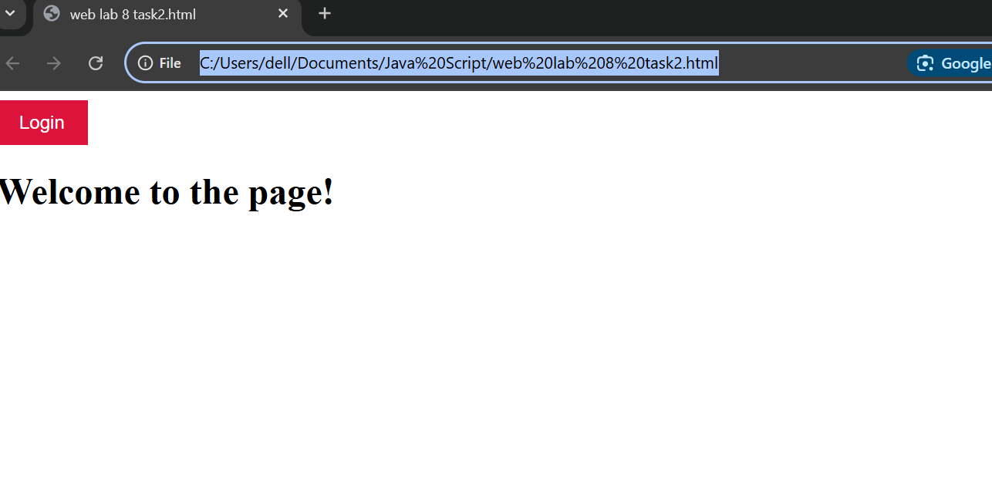

**Task 3:**

<!DOCTYPE html>h

<html lang="en">

<head>

  <meta charset="UTF-8">

  <meta name="viewport" content="width=device-width, initial-scale=1.0">

  <title>Task 3 - Add New Class</title>

  <style>

    /* Initial CSS class */

    .firstStyle {

      color: blue;

      font-size: 18px;

      padding: 10px;

    }

    /* New class to be appended */

    .highlight {

      background-color: yellow;

      font-weight: bold;

    }

  </style>

</head>

<body>

  <p id="styledPara" class="firstStyle">This is a paragraph with the first class style.</p>

  <script>

    const para = document.getElementById("styledPara");

    para.classList.add("highlight");

    console.log(para.className);

  </script>

</body>

</html>

